CS 255 Project Two: System Design Document
Project: DriverPass Management System
Prepared By: Jeremy R. Uphold
Date: October 18, 2026

1. Executive Summary
This System Design Document outlines the software architecture, system behavior, and technical requirements for the DriverPass management system. Incorporating a blended object and process modeling approach, this document details the functional components necessary for development and deployment. Included are UML diagrams illustrating actor interactions, operational workflows, dynamic system communication, and object structures.

UML Diagrams

UML Use Case Diagram
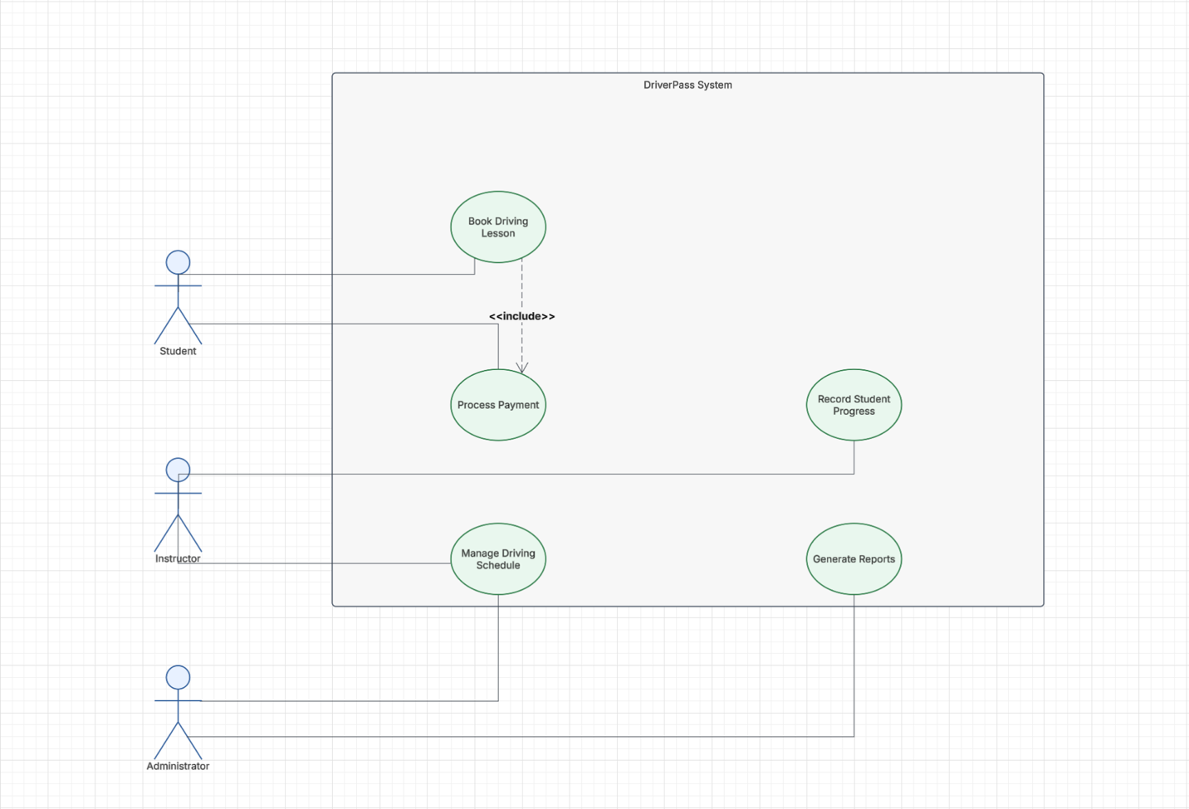

UML Activity Diagrams
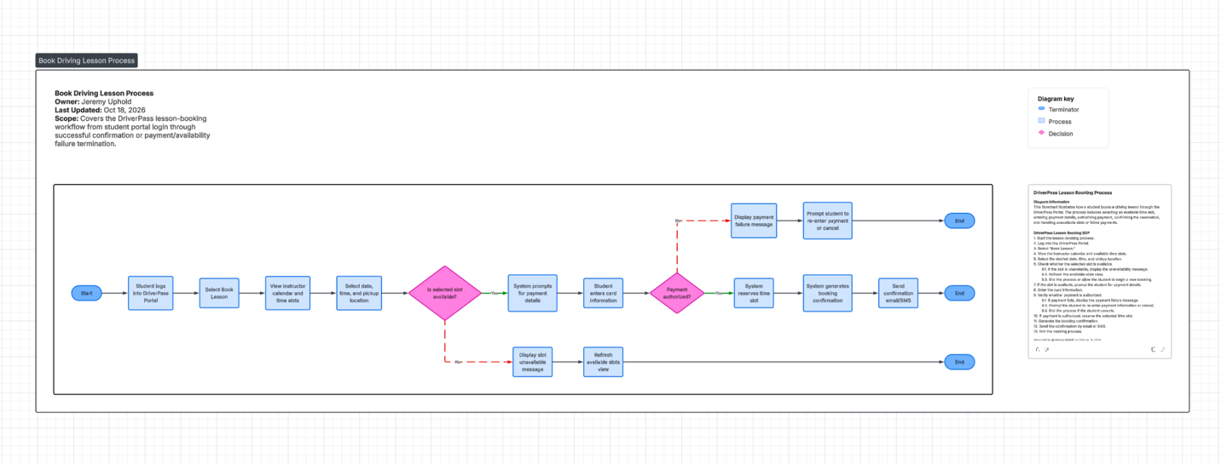
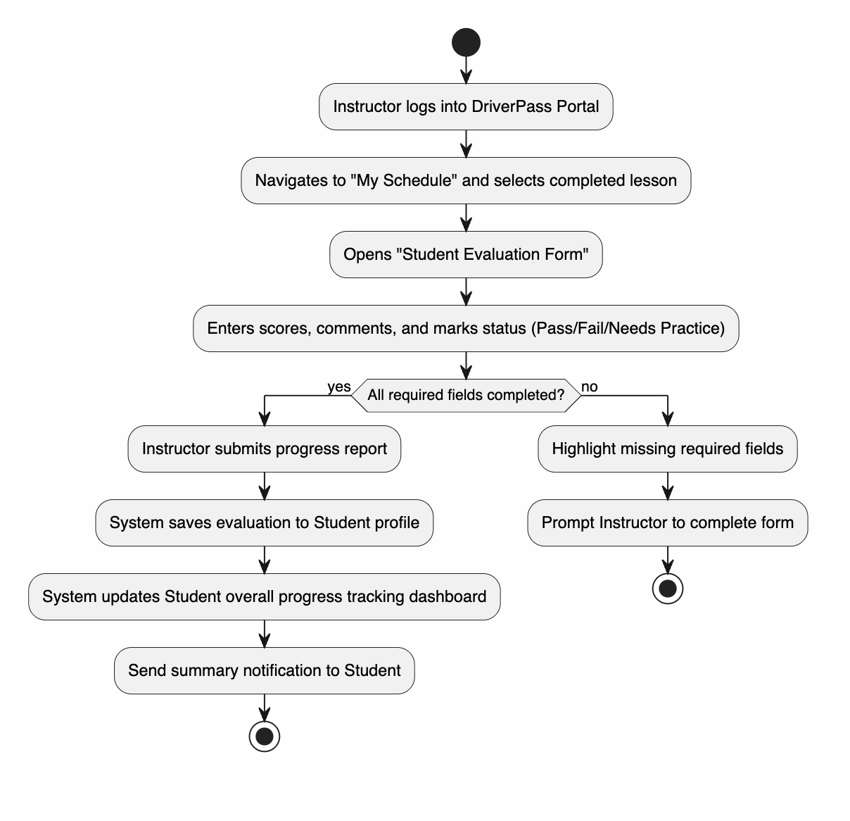

UML Sequence Diagram
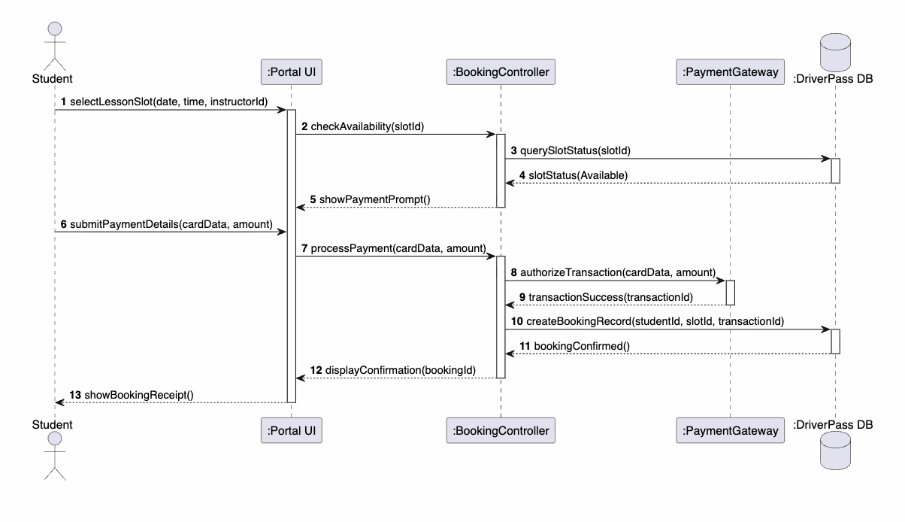

UML Class Diagram
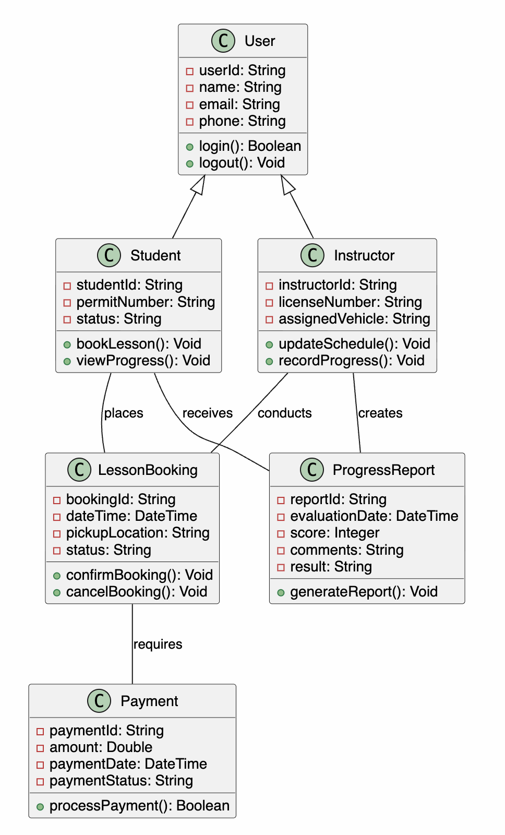

Technical Requirements

A. Hardware Requirements
- Application and Database Servers:
  - Cloud-hosted virtual servers (e.g., AWS EC2 or Azure VMs).
  - Application Tier: Multi-core platform (minimum 4 vCPUs, 16 GB RAM) with auto-scaling groups to manage peak load during business hours.
  - Database Tier: Provisioned relational database instances with high-availability SSD storage (minimum 500 GB storage capacity) with redundant failover units.
- Client Devices:
  - Hardware-agnostic web browser compatibility across standard laptops, desktop systems, tablets, and modern mobile smartphones.

B. Software & Framework Requirements
- Frontend: Responsive Web Application framework built with HTML5, CSS3, and JavaScript/TypeScript (React.js or Angular framework) to ensure cross-device consistency.
- Backend: Object-Oriented runtime engine (Node.js, Python/Django, or Java Spring Boot) hosting RESTful APIs for business processing logic.
- Database Management System (DBMS): Relational Database Management System (PostgreSQL or MySQL) supporting transactional ACID properties for scheduling and financial data integrity.

C. Tools & External Integrations
- Payment Gateway Integration: PCI-DSS compliant payment processing API (e.g., Stripe API or PayPal SDK) for real-time credit/debit card processing.
- Notification System: External communication gateway (e.g., Twilio API for SMS notifications and SendGrid for automated email receipts and booking reminders).

D. Infrastructure & Security Requirements
- Cloud Hosting & Availability: Deployed on Amazon Web Services (AWS) across multiple availability zones with automated load balancing and nightly off-site database backups.
- Security & Encryption:
  - TLS 1.3 encryption protocol for all data in transit.
  - AES-256 encryption standard for sensitive data at rest (user authentication credentials and payment records).
  - Role-Based Access Control (RBAC) enforcing discrete authorization boundaries for Students, Instructors, and Administrators.
  - Continuous automated vulnerability scanning and logging.

